**Question 1**

Implement linear regression to predict student score using the following dataset.

* Use student_scores dataset
* Use packages: NumPy, pandas, scikit-learn.
* Preprocess the dataset.
* Train and evaluate a linear regression model.
* Visualize the results.

**Source Code**

import pandas as pd

import numpy as np

from sklearn.model_selection import train_test_split

from sklearn.linear_model import LinearRegression

from sklearn.preprocessing import LabelEncoder, OneHotEncoder, StandardScaler

from sklearn.metrics import mean_squared_error, r2_score

import matplotlib.pyplot as plt

dataset = pd.read_csv('Week 2\student_scores.csv', header=0)

print(dataset.head())

scaler = StandardScaler()

dataset[['Hours', 'Scores']] = scaler.fit_transform(dataset[['Hours', 'Scores']])

X = dataset[['Hours']]

y = dataset[['Scores']]

X_train, X_test, y_train, y_test = train_test_split(X, y, test_size=0.2, random_state=42)

model = LinearRegression()

model.fit(X_train, y_train)

y_pred = model.predict(X_test)

rmse = np.sqrt(mean_squared_error(y_test, y_pred))

print('RMSE Score: ', rmse)

r2 = r2_score(y_test, y_pred)

print("R2 Score: ", r2)

X_test_orig = scaler.inverse_transform(np.hstack([X_test, np.zeros_like(X_test)]))[:, 0]

y_test_orig = scaler.inverse_transform(np.hstack([np.zeros_like(y_test), y_test]))[:, 1]

y_pred_orig = scaler.inverse_transform(np.hstack([np.zeros_like(y_pred), y_pred]))[:, 1]

plt.scatter(X_test_orig, y_test_orig, color='blue', label='Actual')

plt.plot(X_test_orig, y_pred_orig, color='red', label='Predicted')

plt.xlabel('Study Hours')

plt.ylabel('Scores')

plt.title('Study Hours vs Scores: Actual and Predicted')

plt.legend()

plt.show()

**Output**

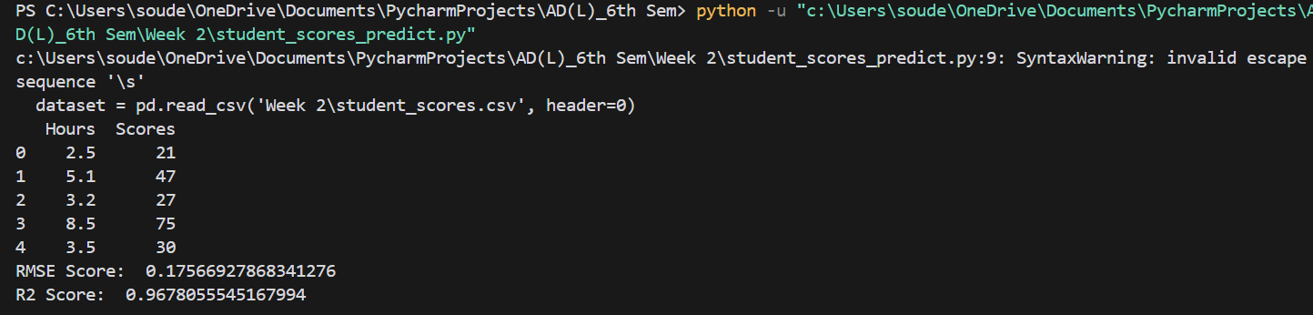*Terminal*

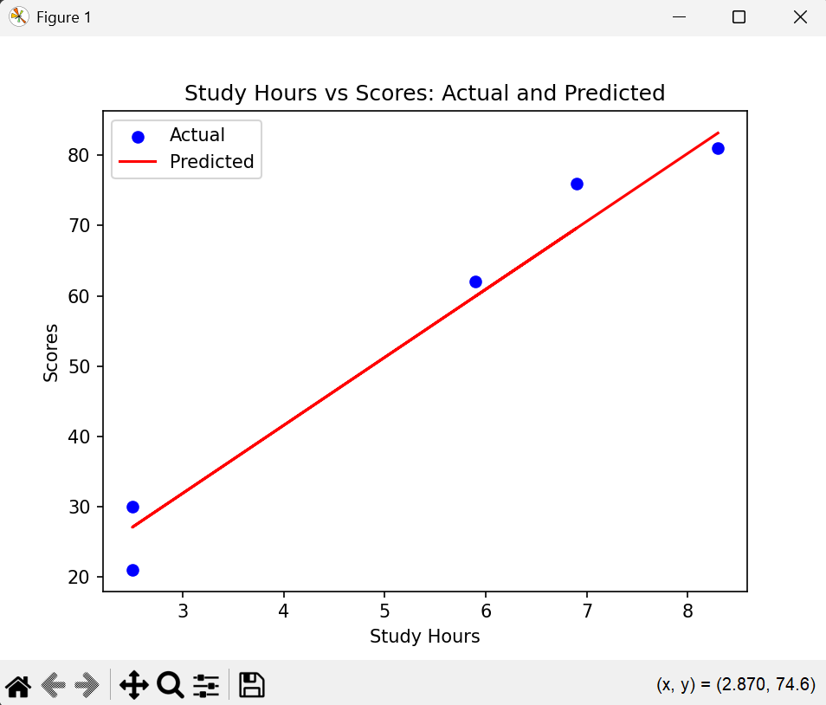*Study Hours vs Scores Regression Plot*

**Question 2**

Implement linear regression to predict weight using the following dataset.

* Use height-weight dataset
* Use packages: NumPy, pandas, scikit-learn.
* Preprocess the dataset.
* Train and evaluate a linear regression model.
* Visualize the results.

**Source Code**

import pandas as pd

import numpy as np

from sklearn.model_selection import train_test_split

from sklearn.linear_model import LinearRegression

from sklearn.preprocessing import LabelEncoder, OneHotEncoder, StandardScaler

from sklearn.metrics import mean_squared_error, r2_score

import matplotlib.pyplot as plt

import seaborn as sns

dataset = pd.read_csv('Week 2\height-weight.csv', header=0)

print(dataset.head(5))

dataset_enc = pd.get_dummies(dataset, columns=['Gender'], drop_first=True)

scaler = StandardScaler()

dataset_enc[['Height', 'Weight']] = scaler.fit_transform(dataset_enc[['Height', 'Weight']])

print(dataset_enc)

X = dataset_enc[['Height', 'Gender_Male']]

y = dataset_enc[['Weight']]

X_train, X_test, y_train, y_test = train_test_split(X, y, test_size=0.2, random_state=42)

model = LinearRegression()

model.fit(X_train, y_train)

y_pred = model.predict(X_test)

rmse = np.sqrt(mean_squared_error(y_test, y_pred))

print('RMSE Score: ', rmse)

r2 = r2_score(y_test, y_pred)

print("R2 Score: ", r2)

plt.figure(figsize=(6, 5))

plt.scatter(y_test, y_pred, alpha=0.5)

plt.plot([y_test.min(), y_test.max()], [y_test.min(), y_test.max()], 'r--', lw=2)

plt.xlabel('Actual Weight (Standardized)')

plt.ylabel('Predicted Weight (Standardized)')

plt.title('Actual vs Predicted Weight')

plt.show()

**Output**

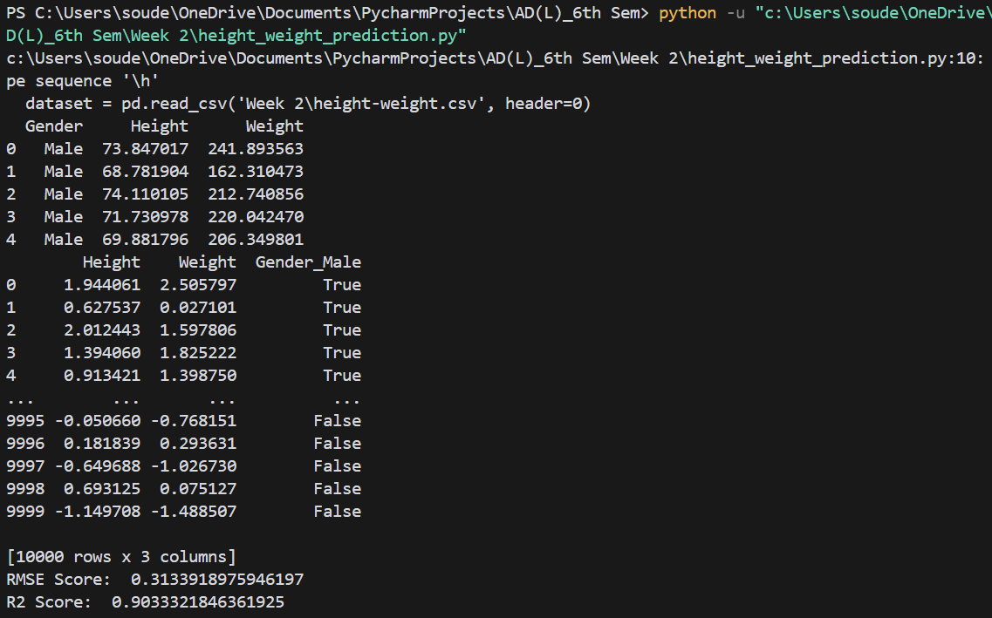*Terminal*

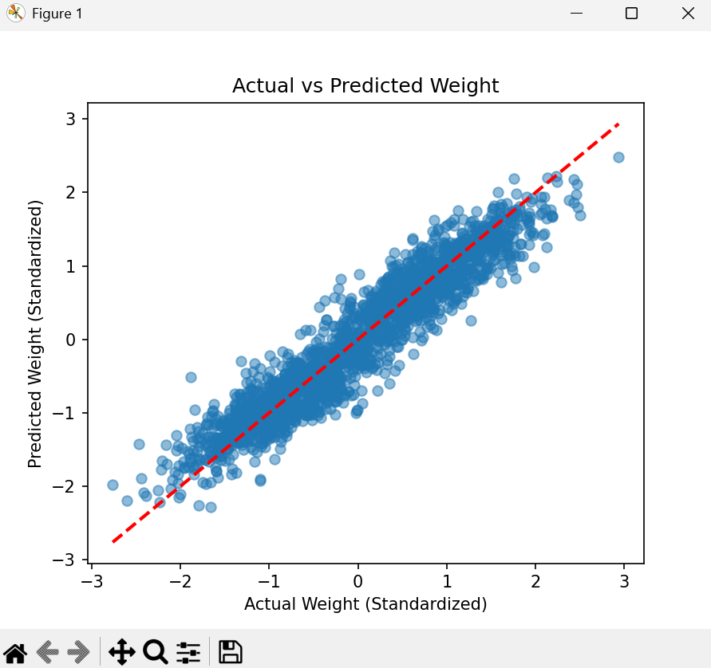*Actual vs Predicted Weight Regression Line*

**Question 3**

Implement linear regression to predict house price using the following dataset.

* Use housing dataset
* Use packages: NumPy, pandas, scikit-learn.
* Preprocess the dataset.
* Train and evaluate a linear regression model.
* Visualize the results.

**Source Code**

import pandas as pd

import numpy as np

from sklearn.model_selection import train_test_split

from sklearn.linear_model import LinearRegression

from sklearn.preprocessing import LabelEncoder, OneHotEncoder, StandardScaler

from sklearn.metrics import mean_squared_error, r2_score

import matplotlib.pyplot as plt

import seaborn as sns

dataset = pd.read_csv('Week 2\Housing.csv', header=0)

print(dataset.head())

categorical_cols = ['mainroad', 'guestroom', 'basement', 'hotwaterheating',

'airconditioning', 'prefarea', 'furnishingstatus']

dataset_encoded = pd.get_dummies(dataset, columns=categorical_cols, drop_first=True)

print(dataset_encoded.head())

scaler = StandardScaler()

dataset_encoded[['area']] = scaler.fit_transform(dataset_encoded[['area']])

X = dataset_encoded.drop('price', axis=1)

y = dataset_encoded['price']

X_train, X_test, y_train, y_test = train_test_split(X, y, test_size=0.2, random_state=42)

model = LinearRegression()

model.fit(X_train, y_train)

y_pred = model.predict(X_test)

rmse = np.sqrt(mean_squared_error(y_test, y_pred))

min_price = y.min()

max_price = y.max()

normalized_rmse = abs((rmse - min_price) / (max_price - min_price))

print('RMSE Score: ', normalized_rmse)

r2 = r2_score(y_test, y_pred)

print("R2 Score: ", r2)

plt.figure(figsize=(10, 6))

plt.scatter(y_test, y_pred, alpha=0.5)

plt.plot([y_test.min(), y_test.max()], [y_test.min(), y_test.max()], 'r--', lw=2)

plt.xlabel('Actual Prices')

plt.ylabel('Predicted Prices')

plt.title('Actual vs Predicted House Prices')

plt.tight_layout()

plt.show()

**Output**

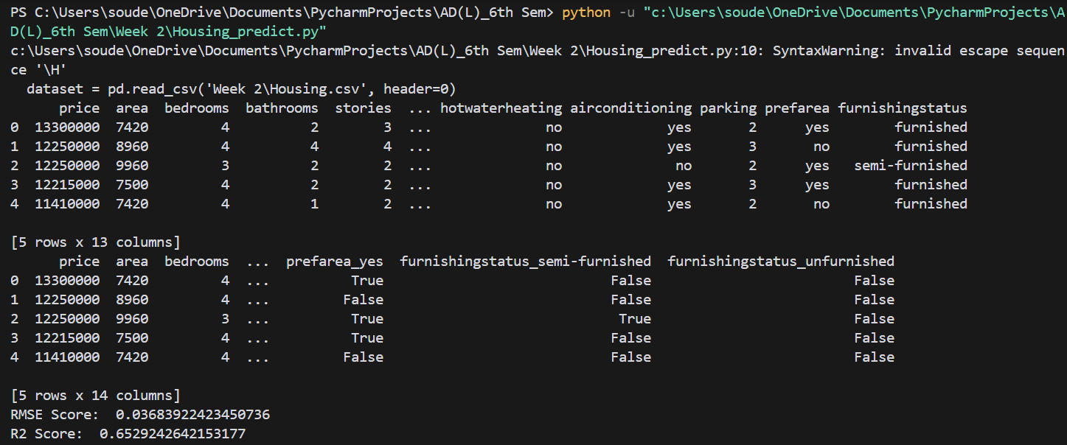*Terminal*

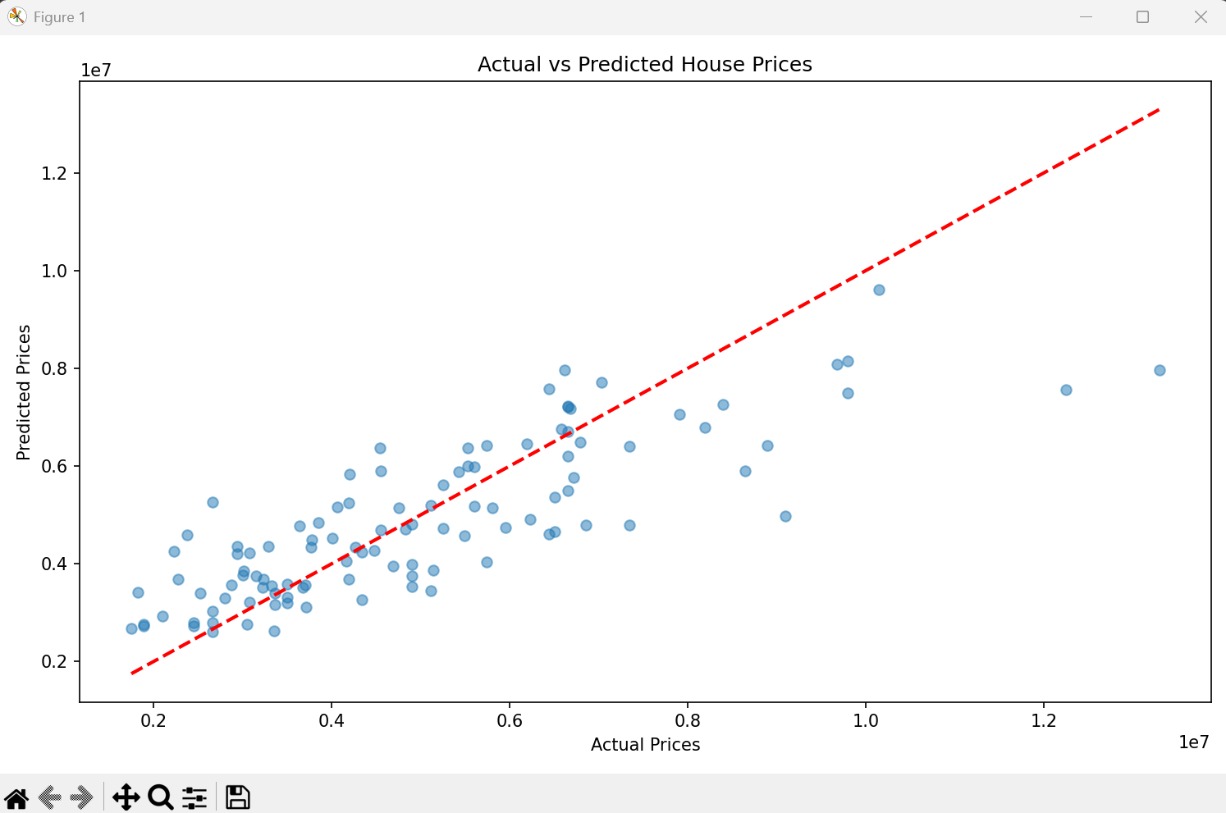

*Actual vs Predicted House Prices Regression Line*